**DAILY ONLINE ACTIVITIES SUMMARY**

|  |  |  |  |  |  |  |  |
| --- | --- | --- | --- | --- | --- | --- | --- |
| **Date:** | **19/06/2020** | | | | **Name:** | Tushit Shukla | |
| **Sem & Sec** | **4 SEM & B SEC** | | | | **USN:** | **4AL18CS093** | |
| **Online Test Summary** | | | | | | | |
| **Subject** | | MES | | | | | |
| **Max. Marks** | | 20 | | **Score** | | 19 | |
| **Certification Course Summary** | | | | | | | |
| **Course** | **PYTHON PROGRAMMING** | | | | | | |
| **Certificate Provider** | | | **Great Learning** | **Duration** | | | **1.5 hr(spent by me on that day to learn)** |
| **Coding Challenges** | | | | | | | |
| **Problem Statement:**  1. Given a positive integer n, count the total number of set bits in binary representation of all numbers from 1 to n.  **Examples:** Input: n = 3 Output: 4 Input: n = 6 Output: 9  **Hint:** Read a positive integer (example: 3 indicates range), so u have to consider 1, 2, 3 as the input convert these numbers into binary and count the number of 1 in that (1- 0001, 2- 0010, 3- 0011) number of 1s from all 3 digit is 4 so the answer is 4 | | | | | | | |
| **Status: Completed** | | | | | | | |
| **Uploaded the report in Github** | | | | **Yes** | | | |
| **If yes Repository name** | | | | <https://github.com/tushitshukla29/lockdown-program> | | | |
| **Uploaded the report in slack** | | | | **Yes** | | | |

**Internal Assessment**

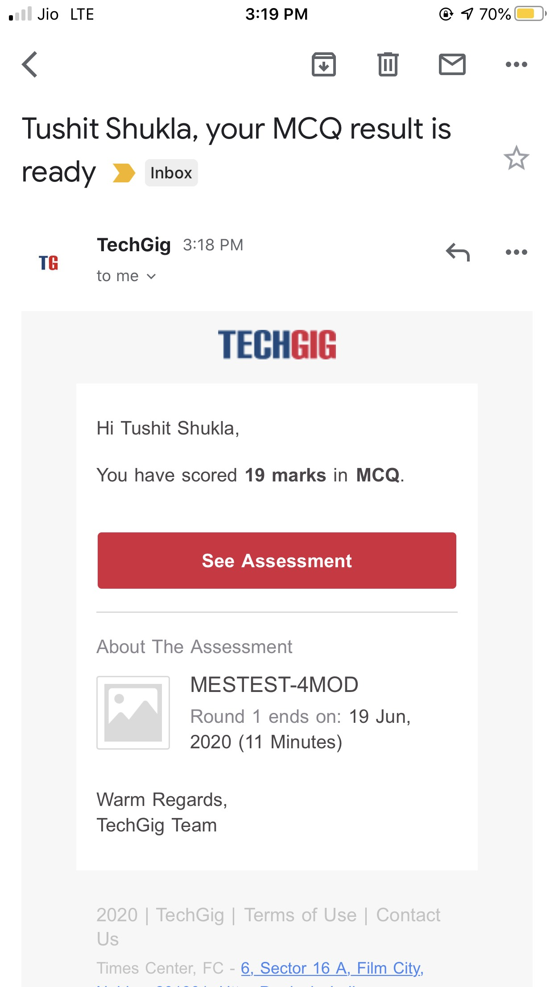

**Online Certification Details**



**Coding Challenge Details**

1. <https://github.com/tushitshukla29/lockdown-program/blob/master/bitCount>